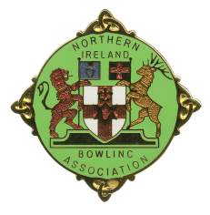
NORTHERN IRELAND BOWLING ASSOCIATION

CHALLENGE CUP ENTRY FORM 2026

Cup Entry Form can be completed online under NIBA Cups Menu

Please enter _____________________________ Bowling Club Side in:

NIBA SENIOR CUP Yes / No*
(Division 1 only)

NIBA INTERMEDIATE CUP Yes / No*
(Division 2 only)

NIBA JUNIOR CUP (16 player) Yes / No*
(Divisions 3 & 4 only)

NIBA JUNIOR CUP (12 player) Yes / No*
(Divisions 5A & 5B only)

* Delete as appropriate

Signed: ______________________________ Honorary Secretary

Please complete and return this form to:

NIBA Challenge Cup Secretary
Robert Watson
2 Uniondale Street
Belfast
BT5 5BP

M: 07907 366457
E: robertwatson248@gmail.com

As soon as possible, but certainly to arrive not later than:

31 JANUARY 2026

ENTRIES NOT RECEIVED BY 31 JANUARY WILL NOT BE INCLUDED IN THE CUP DRAWS FOR THE 2026 SEASON.

