NORTHERN IRELAND BOWLING ASSOCIATION
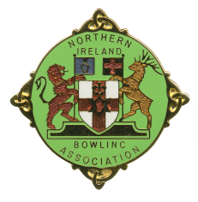
Junior (Under 25) Player Registration Form 2026

Name of Club: ______________________________

List of Club members who are under the age of 25 on 1 April 2026

Name
Date of
Birth
Contact
Number
Rink
Position
P/G
Y/N

Parental / Guardian consent has been obtained for those Players under 18 years.

Signature of Club Secretary: __________________________________

Return to: Honorary General Secretary
Tom Evans
1 Mount Green Cottages
Antrim
BT41 4PW
Mob: 07714235601
Email: tomevans052@aol.com

