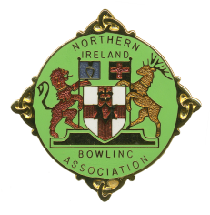
NORTHERN IRELAND BOWLING ASSOCIATION

NIBA CUP ENTRY FORM 2024

Cup Entry Form can be completed online under NIBA Cups Menu

Please complete and return this form to:

Cup Secretary
Tom Evans
1 Mount Green Cottages
Antrim
BT41 4PW

M: 07714 235 601
E: tomevans052@aol.com

As soon as possible, but certainly to arrive not later than:

31 JANUARY 2024

Please enter _____________________________ Bowling Club in:

NIBA SENIOR CUP Yes / No*
(Division 1 only)

NIBA INTERMEDIATE CUP Yes / No*
(Division 2 only)

NIBA JUNIOR CUP (16 player) Yes / No*
(Division 3 only)

NIBA JUNIOR CUP (12 player) Yes / No*
(Division 4 only)

* Delete as appropriate

Signed: ______________________________ Honorary Secretary

ENTRIES NOT RECEIVED BY 31 JANUARY WILL NOT BE INCLUDED IN THE CUP DRAWS FOR THE 2024 SEASON.

